

**UNIVERSITY OF PETROLEUM & ENERGY STUDIES**

**Dehradun**

ACO LAB

**Name- Ritik Kumar**

**Batch- 4 DEVOPS**

**Sap ID- 500097106**

**Roll No- R2142211330**

**SUBMITTED TO- Dr. Hitesh Kumar Sharma**

**EXPERIMENT-2**

**AIM : .dockerignore in Docker**

# Create a Sample Project:

* Create a simple project directory with various types of files, including source code, configuration files, and build artifacts.

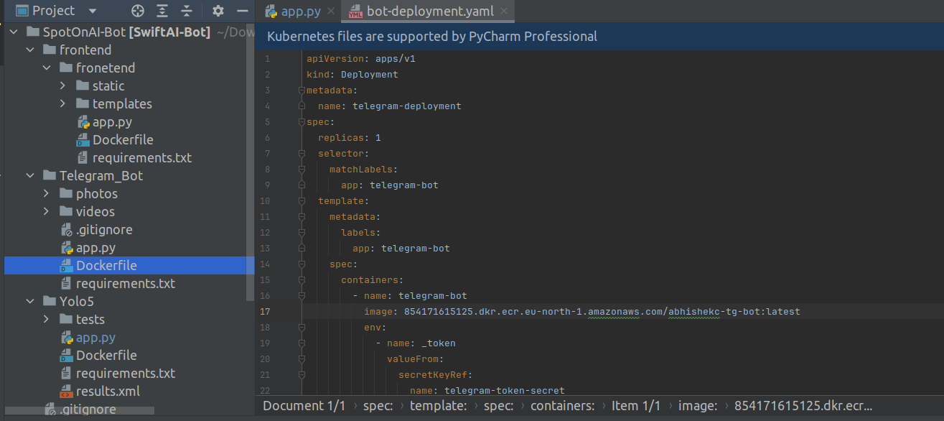

# Create a Dockerfile:

* Write a Dockerfile that specifies the build steps for your application, including any necessary dependencies.

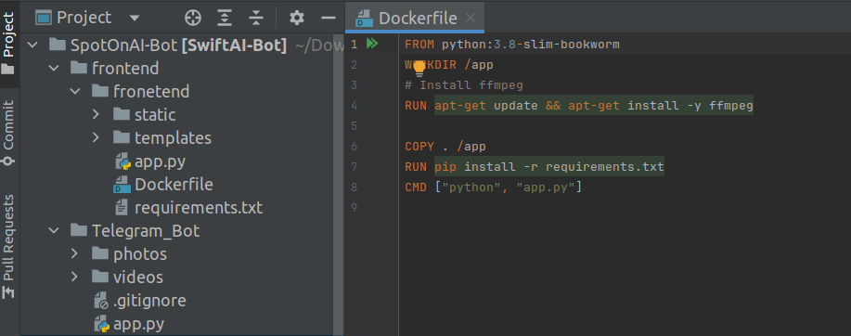

# Create a .dockerignore File:

* Create a .dockerignore file in the root directory of your project.
* Add specific files or directories to the .dockerignore file that you do not want to be included in the Docker image during the build process.

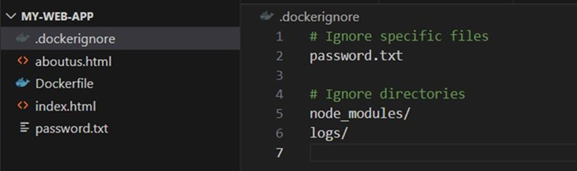

# Build the Docker Image:

* Use the docker build command to build the Docker image from the Dockerfile.

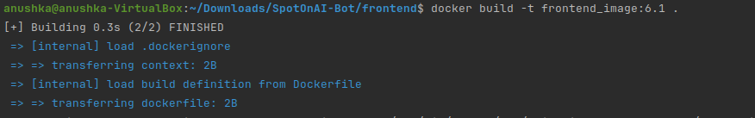

* Observe the build context and check which files are being included in the Docker image.

# Modify .dockerignore and Rebuild:

* Modify the .dockerignore file to exclude different types of files or directories from the Docker image.
* Rebuild the Docker image and observe the changes in the build context.

# Test the Docker Image:

* Run the Docker image as a container using the docker run command.
* Verify that the container works as expected, despite certain files being excluded from the Docker image.

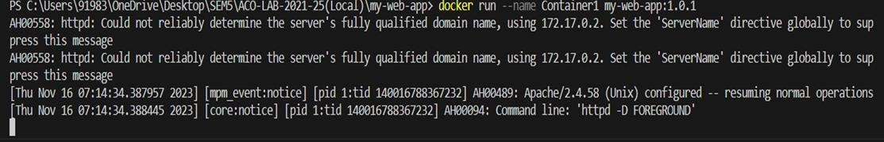

# Optimize the .dockerignore File:

* Experiment with different patterns and wildcards in the .dockerignore file to optimize the build context and reduce the image size.

# Check Image Size and Contents:

* Use the docker image ls and docker image inspect commands to check the size of the Docker image and its contents.

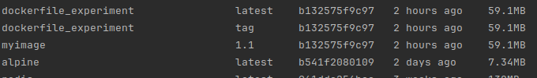

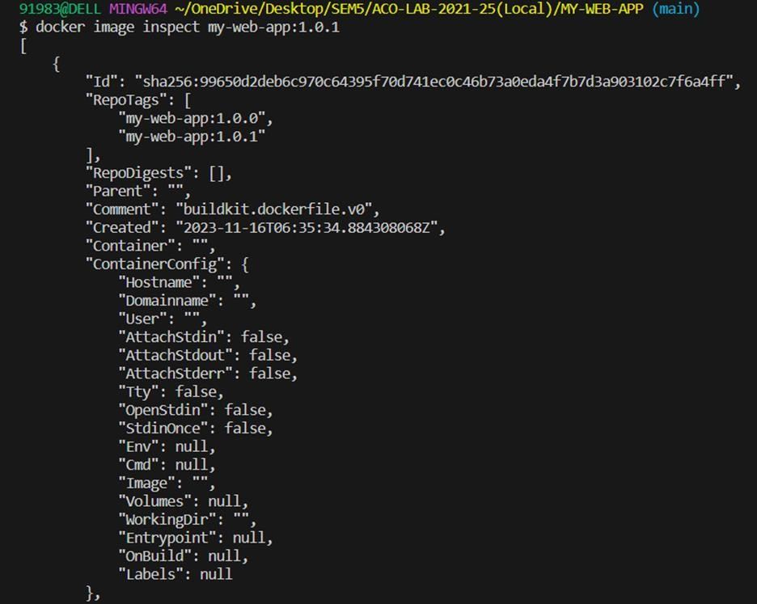

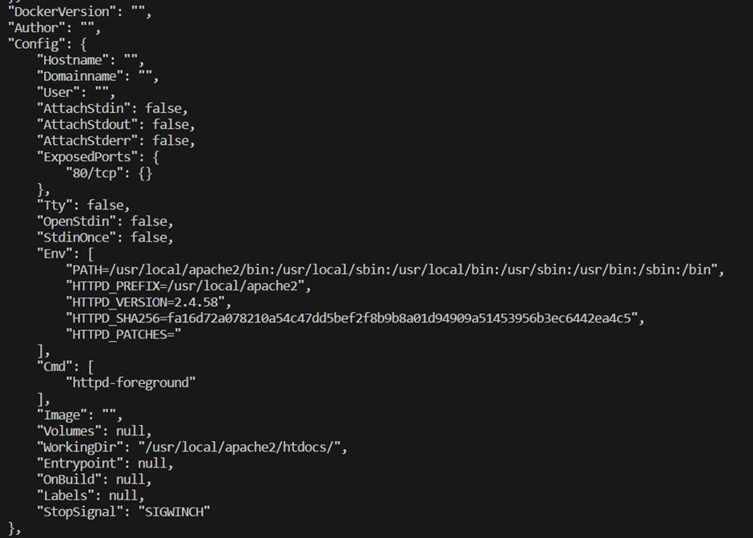



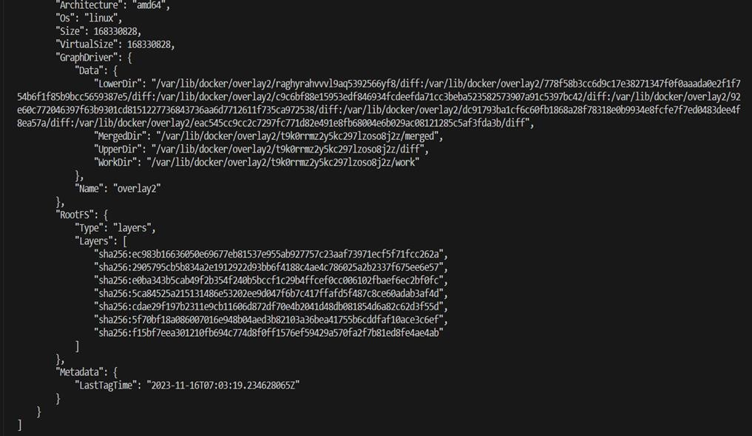

* Command that list the hash id of the image being created and then list the size of the image using its hash id :





# Documentation and Best Practices:

* Document your findings and the best practices for using the .dockerignore file in your projects.

Through this exercise, you'll gain a better understanding of how to use the .dockerignore file effectively to optimize Docker image builds and reduce image sizes. Adjust the exercise based on your specific project requirements.